Dar –Saadani-Bagampoyo-Dar
2nights/3days
Saadani is where the beach meets the bush. The only wildlife sanctuary in East Africa to boast for an Indian Ocean beachfront, it as well possesses all the attributes that make Tanzania’s tropical coastline and islands very popular with European sun-worshipers. Yet it is also the one place where those idle hours of sunbathing might be interrupted by an elephant strolling past, or a lion coming to drink at the nearby waterhole!
Day 1:
Meet your driver and depart to Saadani National Park, check in at Simply Saadani Camp for dinner and overnight
Simply Saadani Camp
The lodge lies on one of the most beautiful stretches of secluded beaches in the Swahili coast with an expansive 10 hectar property including nearly 400m of pristine Indian Ocean beachfront chequered by palm trees. All suite rooms have full ocean views and open up grandly to the stunning sunrise seen each morning over the Zanzibar Channel. Standard rooms and camping facilities are privately and cosily set amongst the shade of the property’s coastal gardens.
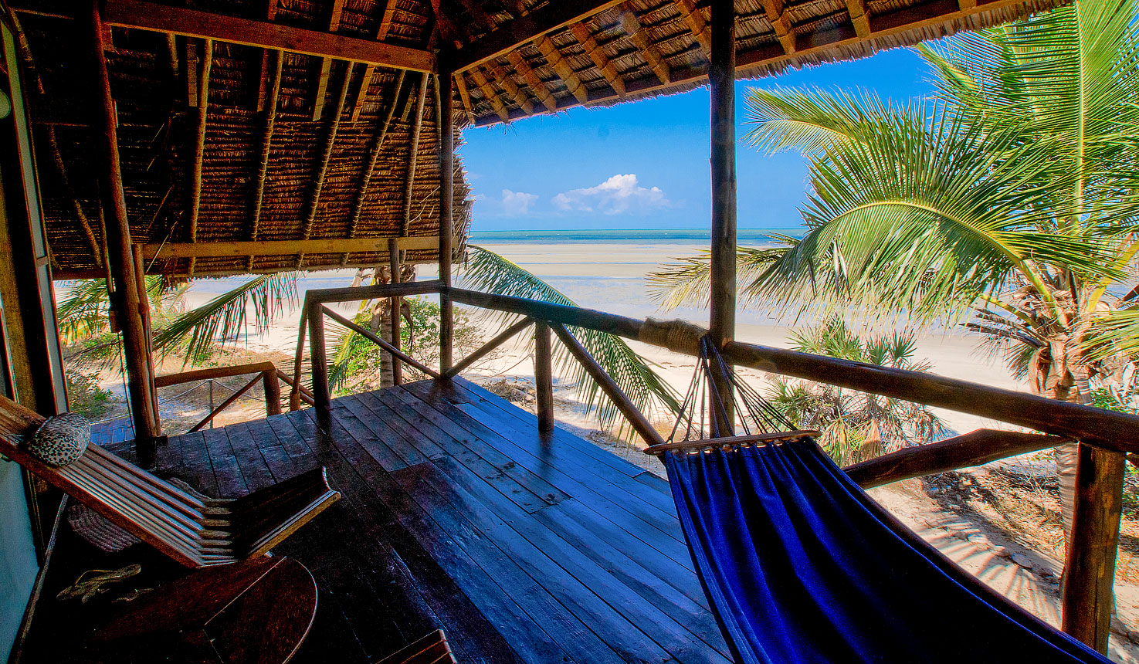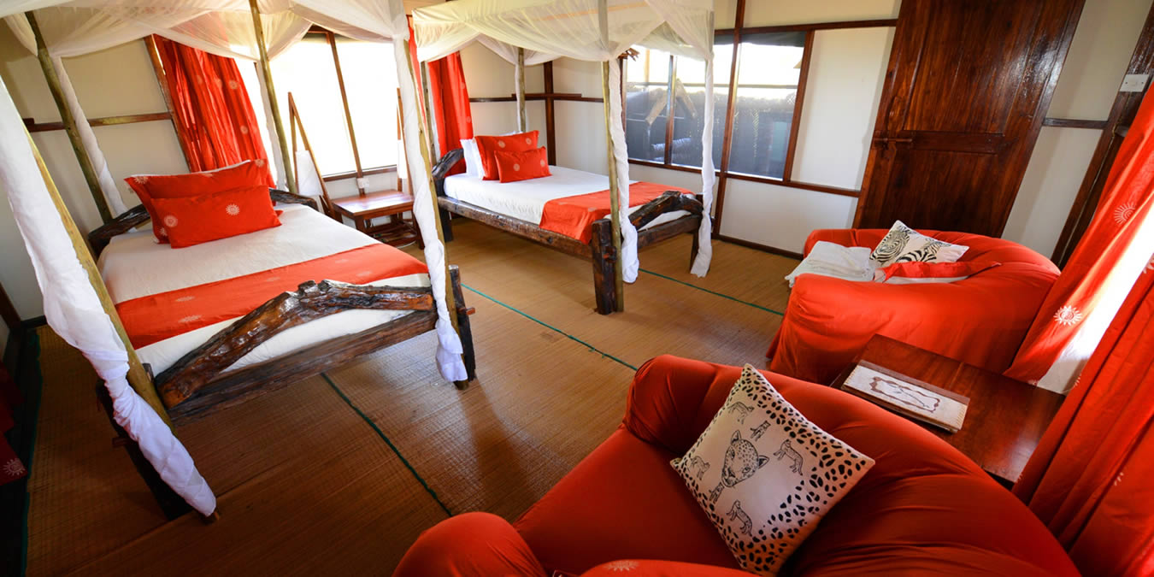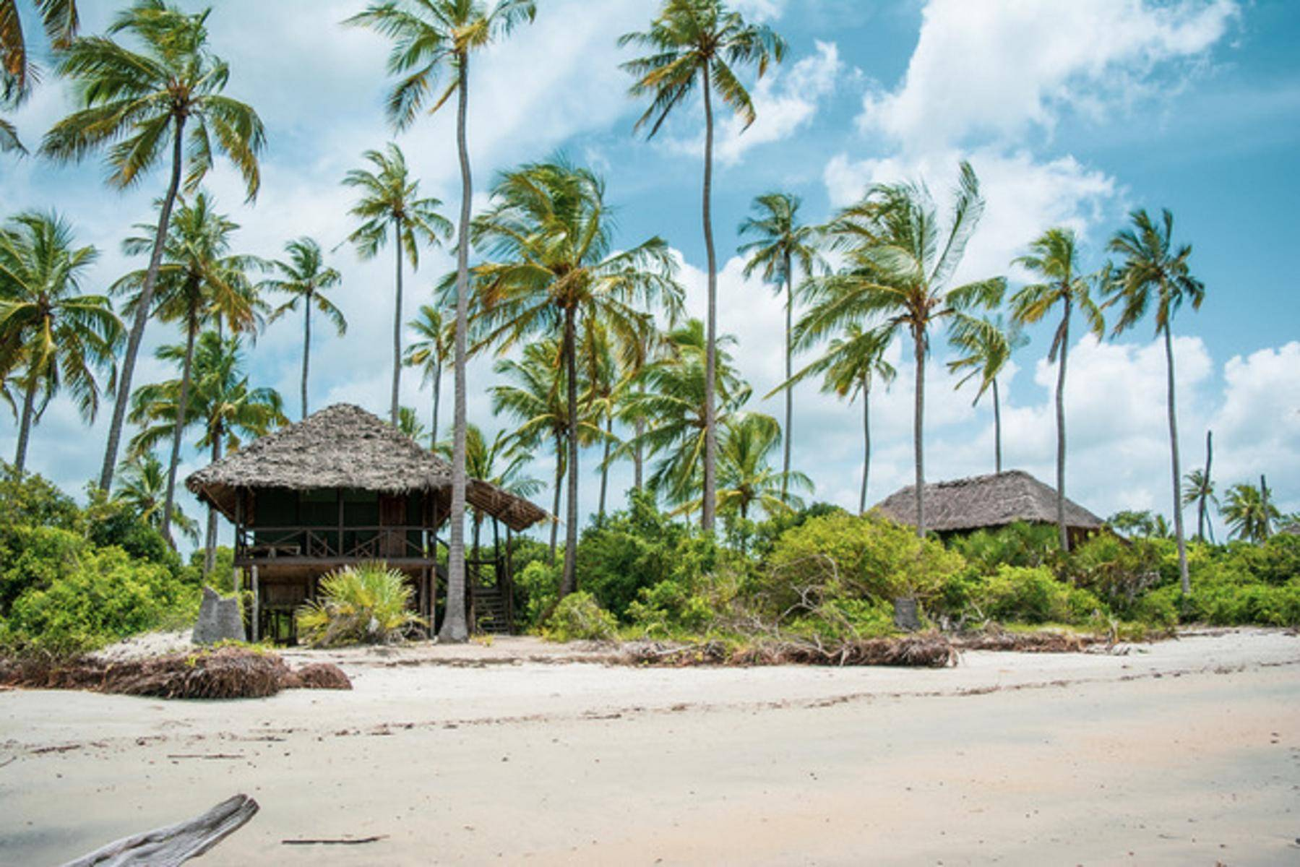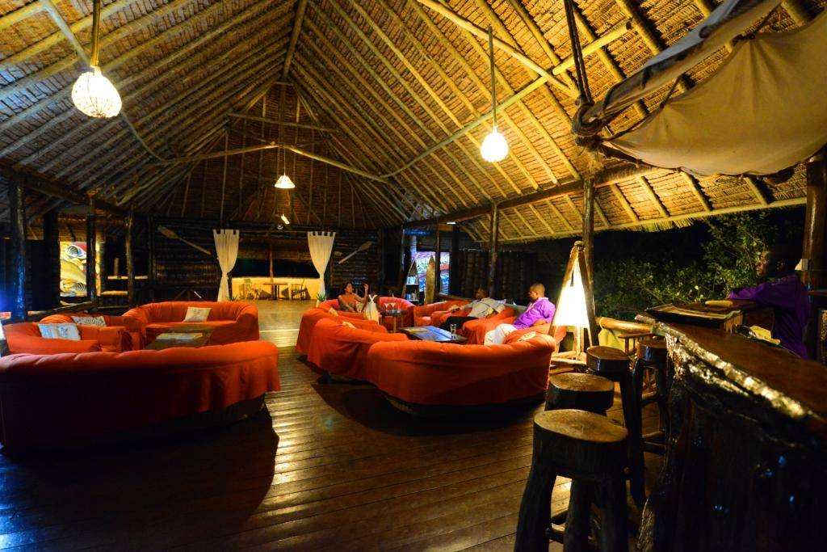
Day 2:
After breakfast, full day game drive with packed lunch afternoon river safari at Wami River. Dinner and overnight at Simply Saadani Camp
Saadani National Park is one of Tanzania's newest national parks. It covers 1000sq.km and is a unique wilderness - the heady mix of beach, bush and river - found nowhere else on the eastern African coastline. It is the range of different ecosystems that set Saadani apart from all other national parks and reserves in Tanzania, in the Wami River hippo and crocodile are prolific, literally a stone's throw from the open sea. Here also there is exceptional wildlife, particularly in the brackish waters of the river mouth, a favourite spot for pelicans and flamingos. Game is plentiful in the bush, predators jousting with plains animals and elephants have been seen on the beach before. The coastline at Saadani stretches to the horizon in both directions, a line of pure white sandy beach. The rich nutrients in the seawater attract prawns and other seafood that make feasts for the dining table. Areas along the coastline provide nesting grounds for turtles and dolphins are often seen around the sand island off shore.
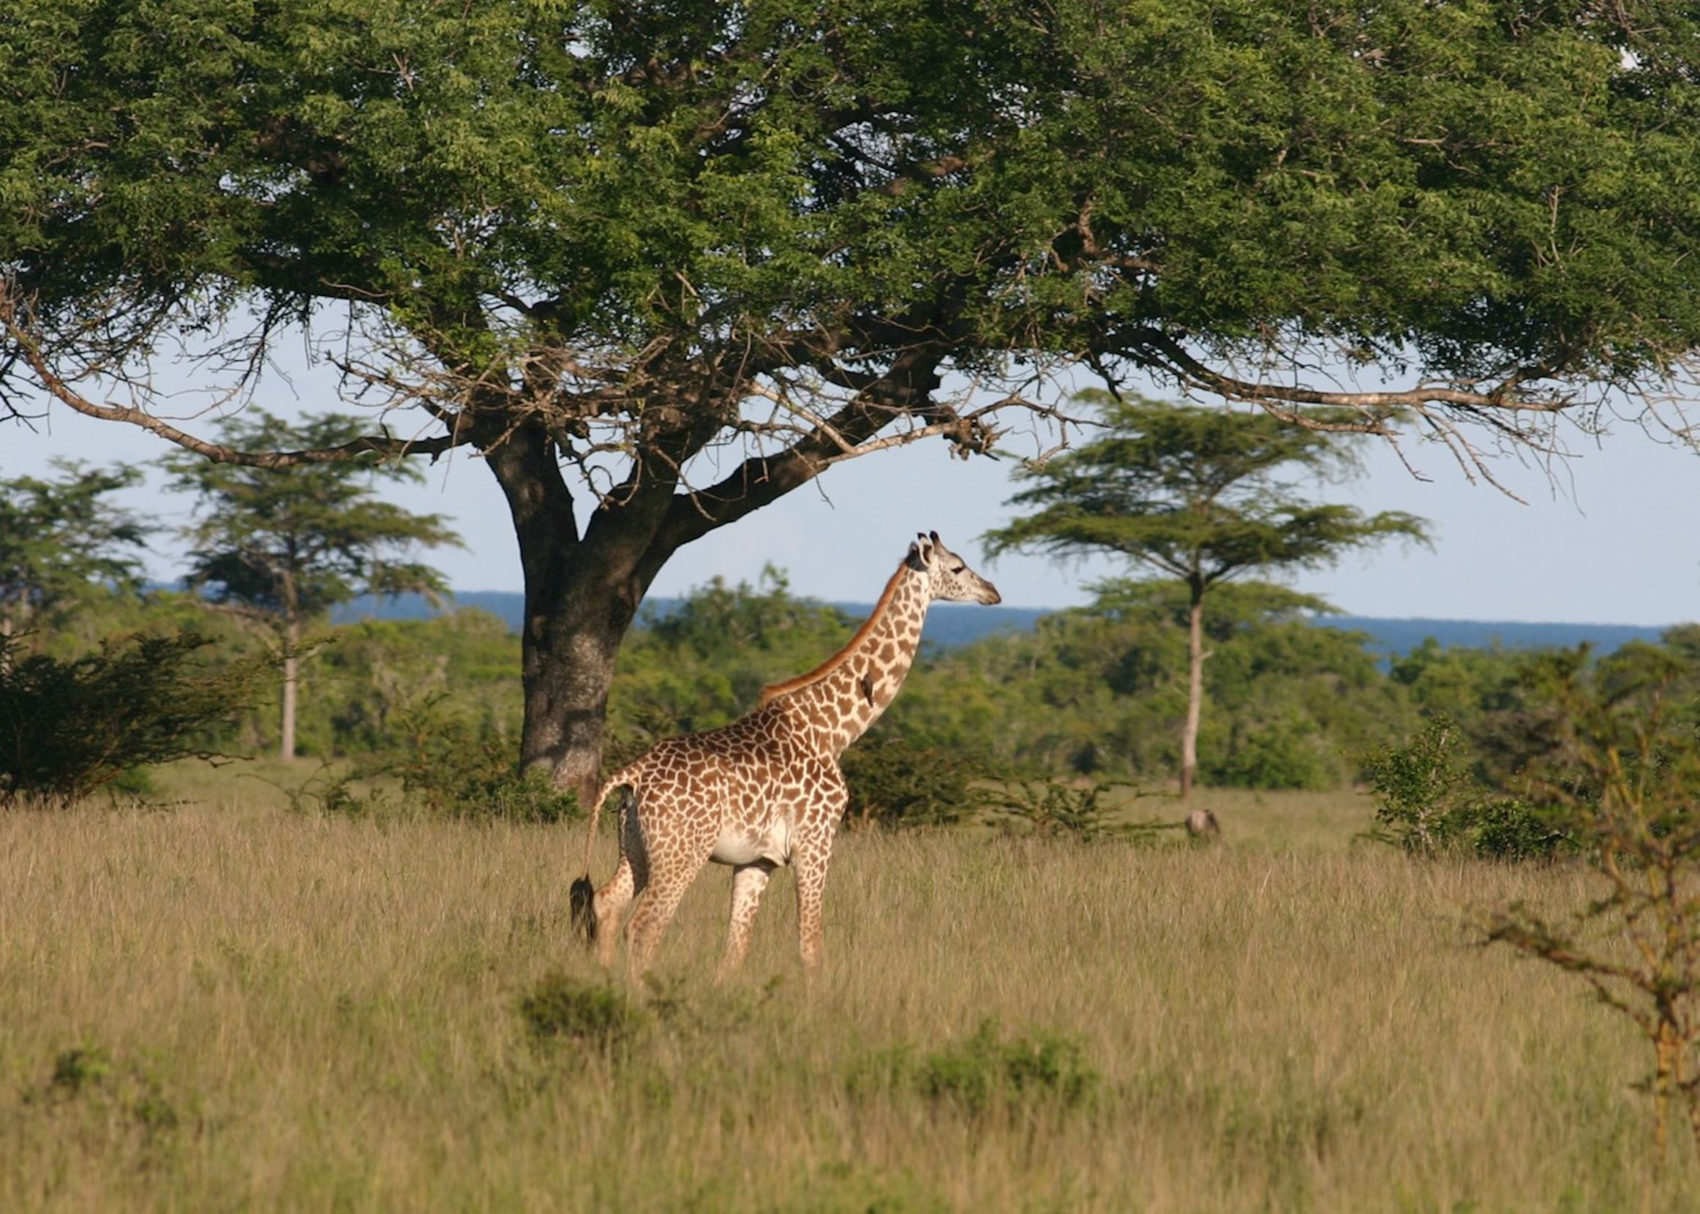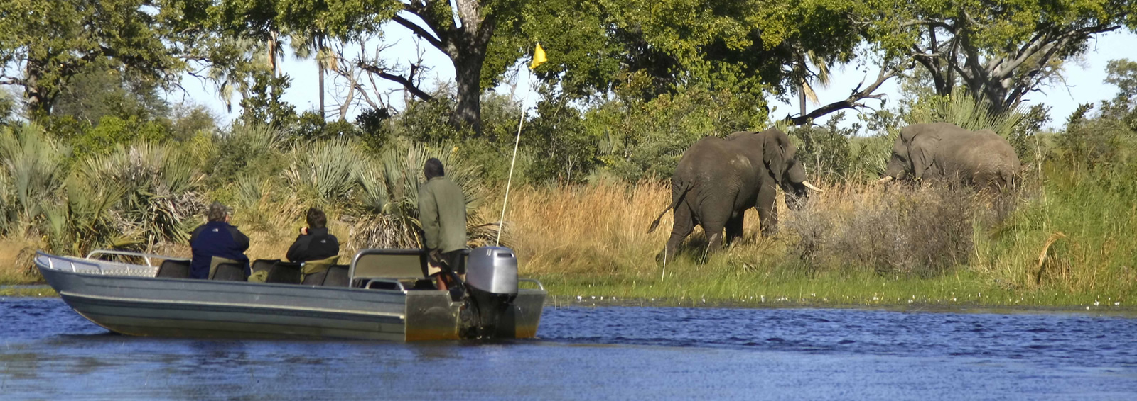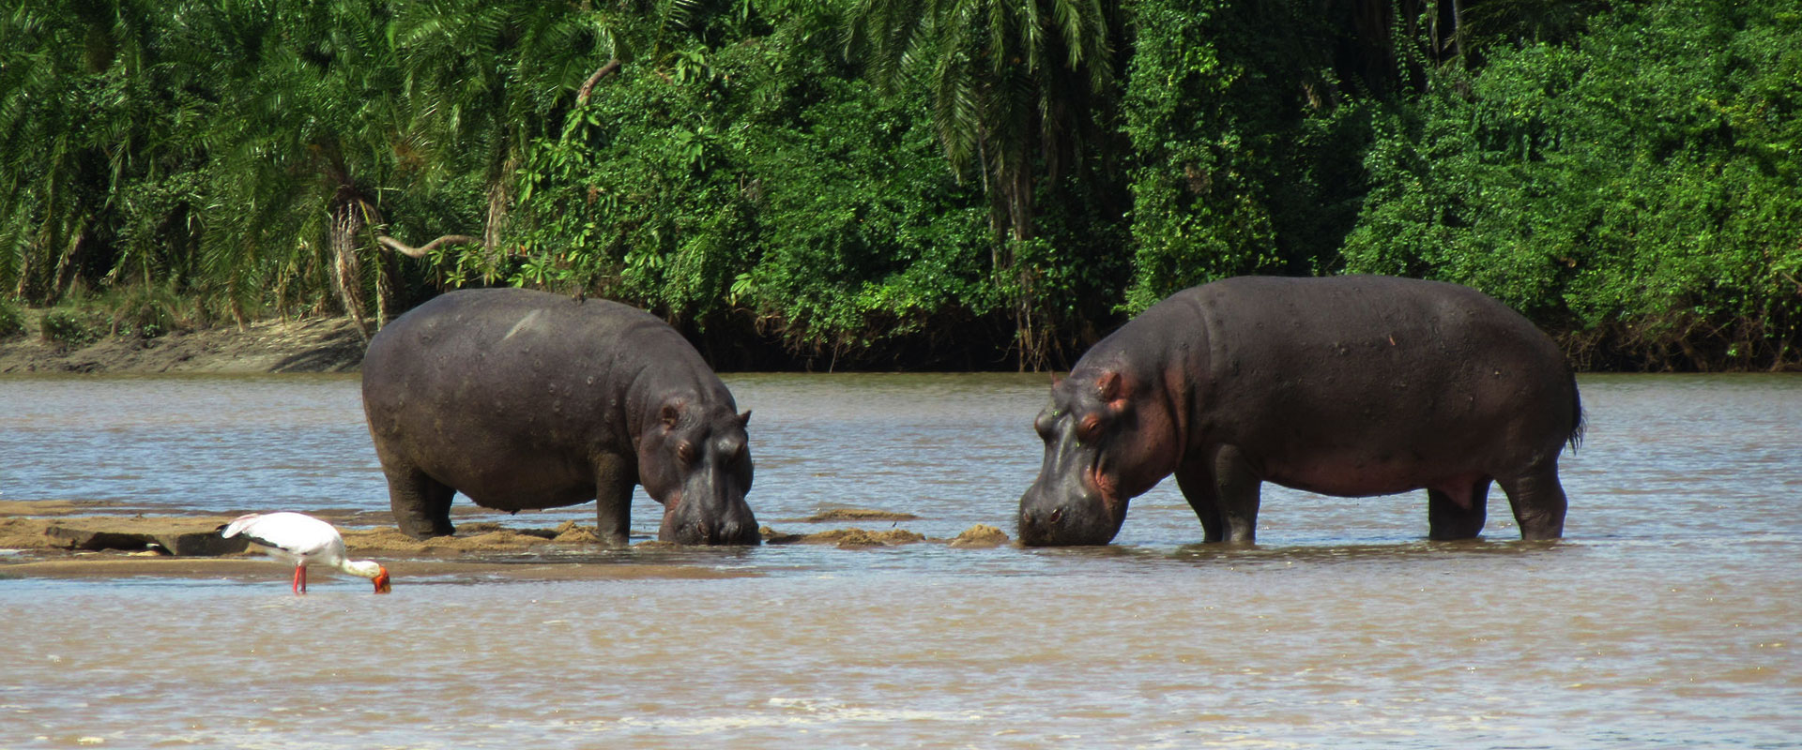
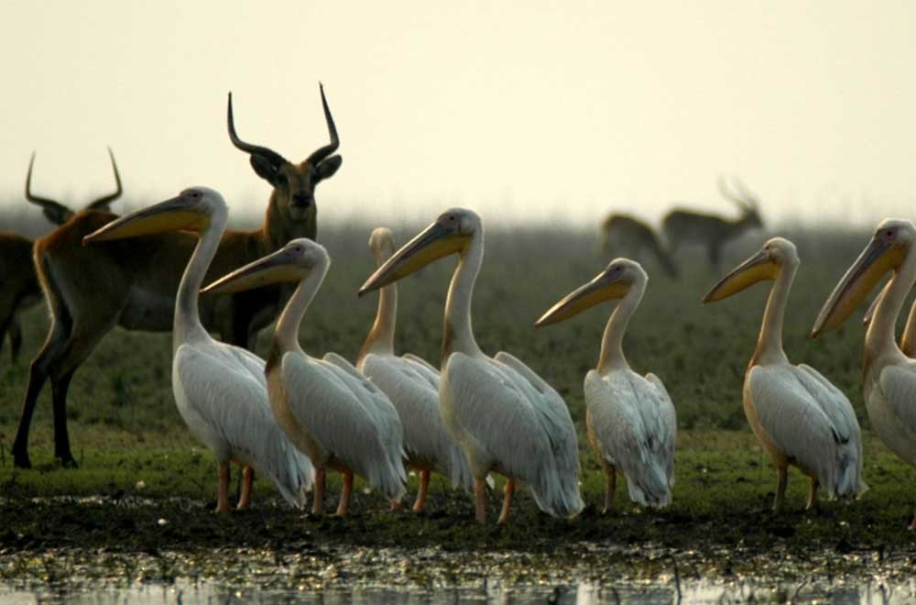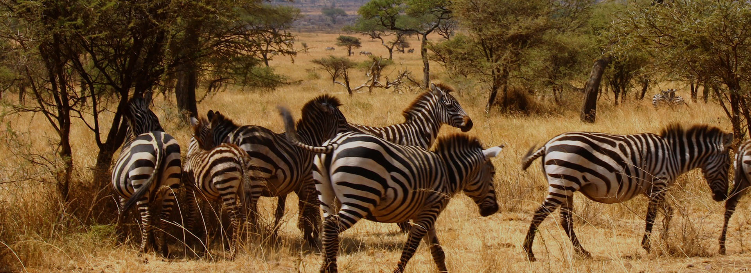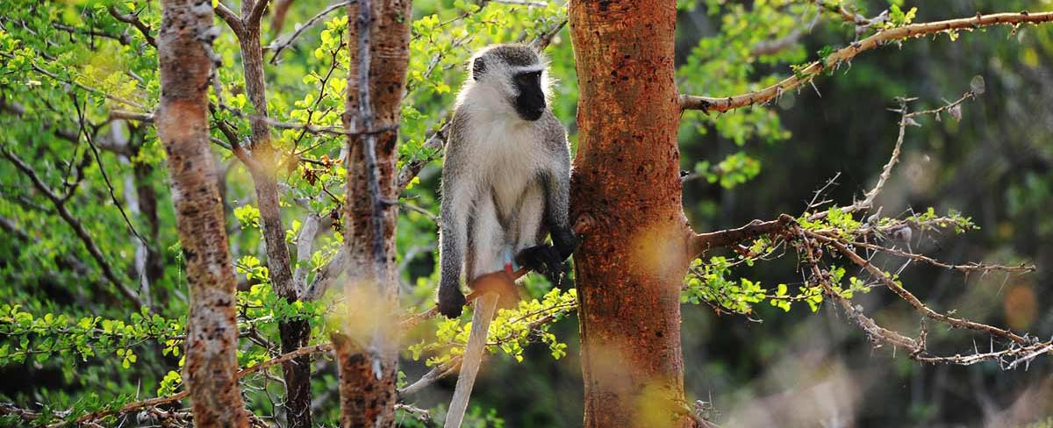

Day 3:
After breakfast, depart to Bagamoyo for a tour before depart back to Dar (fees to be paid directly to the museums, church, Kaole ruins, Crocodile and snake ranch) with packed lunch. Late afternoon drive back to Dar

Inclusive of the above are:
4x4 safari vehicle and English speaking driver/guide, game drives as per itinerary,
2Night full board accommodation at Simply Saadani Camp base on full board and entrance park fees
Boat safari at Wami River, and Boat fees
Bagamoyo tour
Mineral water during safari
Tourism development levy

Not inclusive are:
Entrance fees in Bagamoyo
Alcohol drinks
Laundry
Medical and luggage insurance
Tips and other personal expenses

