'Mini Montenegro'

4 days - 3 nights

In this arrangement, we choose the most beautiful areas of Montenegro for you, compound of the south and the north with accommodation in the main and largest city of Montenegro - Podgorica. With "Monte Mare Travel", you will be able to meet Podgorica where you will be accommodated, then the former capital of Montenegro - Cetinje, the most famous Montenegrin village Njeguši - the birthplace of Peter II Petrović Njegoš, drive to the famous Lovćen serpentine, visit Kotor - a city on the World Heritage List of UNESCO, Budva - a metropolis of Montenegrin tourism. We will head to the north side of this beautiful little country and visit the Morača Monastery (XII century), drive along the Platije Canyon, one of the most attractive canyons in the region, visit the National Park Biogradska Gora, where the central place has occupied one of the last three rainforests in Europe, a botanical garden with a great scientific, cultural and educational significance and the city of Kolašin, which many call the air spa due to the specificity of the climate. You will also be able to enjoy traditional Montenegrin specialties: ham, homemade cheese, honey and national dishes, wines and brandy, all in a unique ambience of taverns and restaurants.

Podgorica is the capital of Montenegro located in the center of this country, at the intersection of several important road directions that lead from the sea to the continental part of the country. It is the main administrative, political, economic, traffic, scientific and educational - cultural center of Montenegro. The city is close to winter centers in the north and resorts in the Adriatic Sea. It offers a wide range of discoveries to visitors through cultural heritage, archaeological sites, monuments, museums, and through nature in a national park, active holidays, views of canyons, rivers and bridges, as well as enjoyment of traditionally produced food and wine. In Podgorica there is one of the largest and most beautiful vineyards in Europe – ’’13. Jul Plantaže’’, covering 2,300 hectares, and all who visit the ‘’Šipčanik’’ basement have the opportunity to experience the impressive ambience of a unique wine cellar in Europe, enjoying the unforgettable smells and tastes of Montenegro.
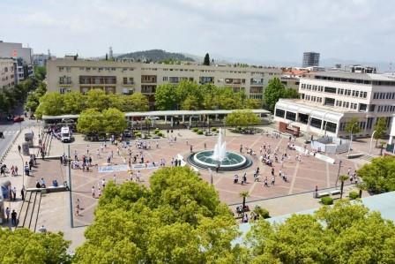

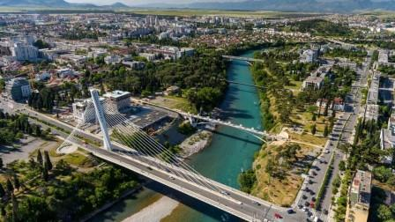

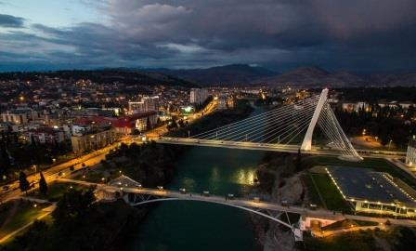

Cetinje is a town situated below the mountain Lovćen, at an average altitude of 670 m. Cetinje is the old Kingdom of Montenegro. It was founded in the 15th century and became the center of Montenegrin life and its culture. Today it is a city museum with beautiful monuments, promenades and nature under the huge mountain Lovćen. Cetinje is the former capital of Montenegro. The most important monument of Cetinje is Cetinje Monastery built in 1701 - dedicated to the birth of the Virgin. After the Monastery, the most important architectural monument of the town is Biljarda - the residence of Peter II Petrović Njegoš. It was built in 1838. Although the headquarters of the Montenegrin Senate and foreign missions were located in the building, she remained most remembered by the Billiards Hall, which this extraordinary writer, bishop, philosopher and statesman liked to play. Immediately across the street there is the King Nikola’s Museum in the building from 1867 which in the past served as the residence of Montenegrin rulers, and today it has a permanent setting, but also a gallery in which traveling exhibitions are shown. This small city, enriched with the greenery and architecture of the 18th and 19th centuries will surely draw your attention at first glance, through a rare combination of nature and culture, museums, art faculties, parks, promenades.

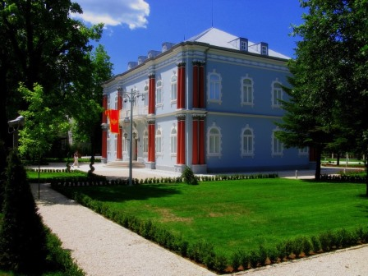

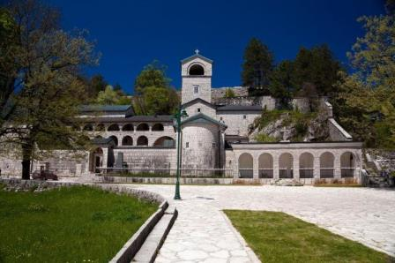

At the foothill of mountain Lovćen, at 900 m above sea level, there is the most famous Montenegrin village Njeguši, from where Petrović dynasty comes, which ruled for 300 years in Montenegro. Near the road that passes through the village, there is a house in which Njegoš was born, a typical Montenegrin house of a wealthy family. In it, today is a museum in which besides household items, literature works are exhibited. Among them it is the first edition of the book ‘’Gorski vijenac’’, printed in Vienna in 1847. Also, you can see Njegoš's bronze statue of the famous sculptor Ivan Meštrović, portraits as well as the genealogical tree of the Petrović family.

The village of Njeguši is today a quiet tourist place with about 200 inhabitants. It is known for the traditional production of prosciutto, homemade cheese and honey. Here you can see how to prosciutto is produces, buy it and enjoy the tastes of organic traditional Montenegrin products in one of the local taverns. One thing is undoubtedly, you will be enchanted by the unique taste of the prosciutto from Njeguši, produced in the ideal conditions of mixed cold mountain air with the sea.

At the end of the 19th century, more precisely in 1884, after five years of work, on the slopes of Lovćen it was constructed road which connected Kotor and Njeguši village. This road is known today as the famous Lovćen serpentines. Many influences of various civilizations arrived in Montenegro by this way, such as: good wines from the French, silk fabrics of the Far East, the first ski from Norway. One of the biggest construction projects in the Montenegrin history of Montenegro, today is more tourist attraction than traffic road. It witnesses of human persistence that in a perfect harmony with nature combine uncombined.

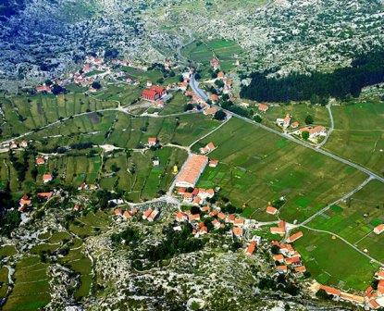

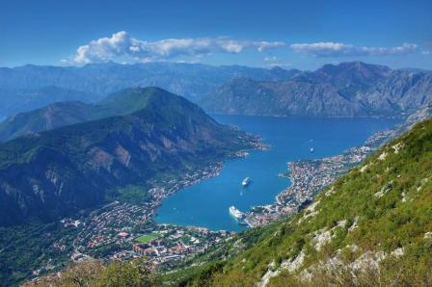

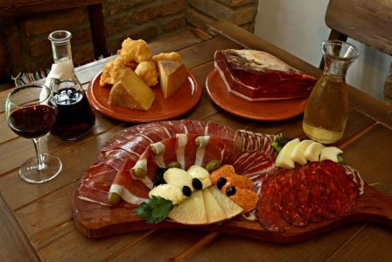

Kotor is a city and municipality on the coast of the Boka Bay in Montenegro. Situated in one of the most beautiful bays, this town of merchants and sailors has a lot to show. Kotor Bay (Boka Kotorska) is one of the deepest and longest in the Adriatic Sea and is often called the southernmost fiord of Europe. The old Mediterranean archipelago, surrounded by impressive city walls, is very well preserved and included in the UNESCO list of the World Cultural and Natural Heritage.

Between 1420-1797 Kotor was surrounded by Venice and Venetian influence stands out in urban architecture. Throughout the city, there are buildings, intertwined with streets and squares, and on one of them there is a Cathedral of Saint Tryphon (XII century) - the recognizable symbol of the city - dedicated to the patron of the town. The most imposing are, however, the city walls that surround the city, about 5 km long, high to 20 and wide to 10 meters. Climbing along the walls, you will arrive at the San Giovanni fortress at about 280m above sea level from which you can see the enchanting panorama.

Various events, carnivals and festivals organized each year give this city extra charm.
In recent years, it has been an increasing number of tourists who are attracted to the natural beauty of Boka Bay, as well as the old town of Kotor, which is not surprising, since Kotor has been on the top list of the most visited destinations for years.

It was nominated for the title of the best European destination in 2019, following the results achieved in 2018 at a competition conducted by European Best Destinations - EBD.
The old town of Kotor also has a great number of nicely arranged restaurants and hotels where you can taste traditional specialties as well as varied Mediterranean food.

Simply, Kotor is the city to which the visit is unavoidable!

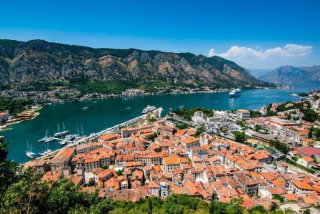

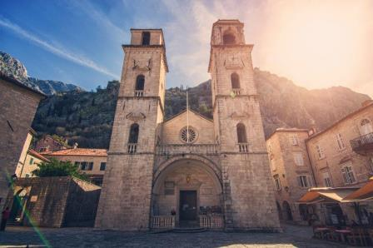

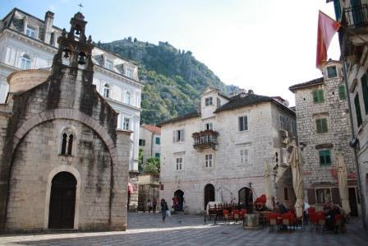

Budva is a coastal city on the Adriatic coast in Montenegro. This city dates back 3,450 years ago and is one of the oldest cities on the Adriatic Sea. The area around the city, along the coast, is called Budvanska Riviera. The Riviera is the center of

Montenegrin tourism, known for its sandy beaches and night life, the area of ​​hotels and restaurants that separates the beautiful coast from high mountains.

The name Old Town, Budva was worn in the Middle Ages, and most of the architecture of this city was of Venetian origin. Doors, windows, balconies and many other parts of the building are of Roman style. Budva has a large number of cultural and historical monuments, monasteries and churches that document the historical and social events in the area of ​​the Budvanska Riviera. Among the most famous churches are the church of San Giovanni, built in the seventh century, the church of Santa Maria "in Punta" from 840, the church of the Holy Trinity from 1804. The most famous part of the city walls is called Citadela and is an interesting tourist attraction. The city abounds in beautiful beaches of which the most famous are: Mogren, Slovenska, Bečići, Jaz...

Today Budva is a tourist center, a monumental resort, a city theater and a prestigious town on the tourist map of Europe and the world. Budva is often referred to as the "metropolis of tourism" because it is the most visited destination in Montenegro and one of the most visited ones on the Adriatic, and it is often given epithet like "Queen of the Adriatic".

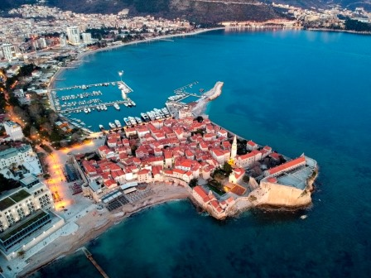

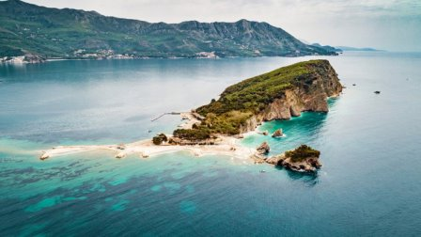

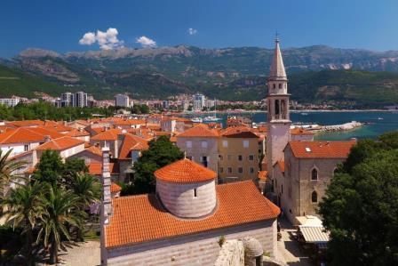

Monastery Morača (built in 1252) is one of the most monumental Orthodox medieval monuments of Montenegro. It was built by Stefan Nemanjić, the son of king Vukan. It is located on the right side of the river Morača, in the expanded part of the canyon, on the natural valley of picturesque landscapes, in the municipality of Kolašin. The monastery complex consists of a central church dedicated to the Virgin, a small church of St. Nikola and a part for overnight stay.

Below the monastery, there is the waterfall of Svetigora which created a nearby brook that flows into the river Morača. By visiting this monastery you will feel the modest life of the seniors in harmony with nature.

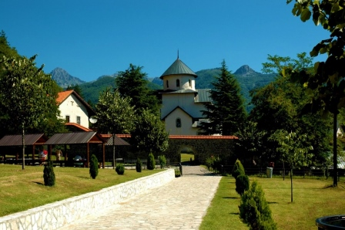

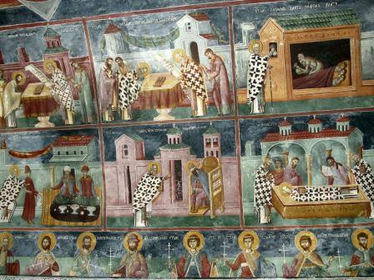

Kolašin is a town in the north of Montenegro, 72 km away from Podgorica. It was founded in 1651 by the Turks as a fortification and a caravan station from the coast to the north. It extends in the upper and middle courses of the Tara and Morača rivers. It is surrounded on all sides by mountain peaks and ridges of Sinjajevina, Bjelasica, Komovi and Vučje. For mountaineers and tourists, the peaks of these mountains are especially attractive: the most famous Jablanov vrh (2203 m) on Sinjajevina, Troglava Bjelasica (2075 m) and Zekova Glava (2116 m), then Komovi (2484 m) . Kolašin is at 954 m above sea level and offers excellent holidays in winter and summer. In Bjelasica there is a well-known ski resort just a few kilometers from the city. Many people call this city an aerial spa due to the height and extraordinary climatic conditions. There is a unique botanical garden in Kolašin, which is a true treasure of flora of the continental part of Montenegro.

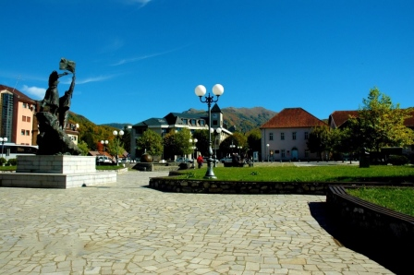

A special attraction for tourists is the National Park Biogradska Gora, located in the north-east of Montenegro, between rivers Tara and Lim in the central part of the mountain Bjelasica. It is the first declared national park in Montenegro in 1952 and it occupies an area of ​​ 5650 ha. His protection dates back to 1878, when this area was given to the lord of Montenegro Prince Nikola Petrović, and it has since become the "Knjažev zabran" – ‘’Prince’s reserve’’. Biogradska gora simply captures its pure beauty. Surrounded by mountain heights, centuries-old forests and meadows, sprinkled with streams and coves, decorated with beautiful lakes, is a magnificent gift of nature. Green is dominated by a combination of unique forest ecosystem and meadow vegetation areas. The most important natural value of this national park is the rainforest of Biogradska gora, which covers an area of ​​1600 hectares. It is one of the last trees in Europe and has the character of a strictly protected reservation.

In the heart of the forest there is a beautiful Biogradsko lake, the largest and most famous of many glacier parks in the area of ​​the national park. It is located at an altitude of 1094 m. In clean water on the lake, all the beauty of the ancient forest is reflected, giving it a blue-green color and creating a special landscape for the visitors. Ice forms of relief, such as peaks high and over 2,000 meters and glacier waves with several fairytale glacier lakes, give this region unparalleled beauty.

The rich flora and fauna of the National park Biogradska gora made it very interesting and attractive to many scientists, scientific observations and studies, as well as sightseeing tours and visits of nature lovers.

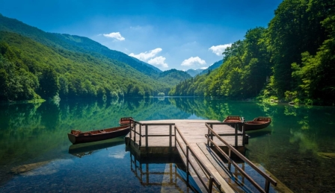

ITINERARY:

Day 1 - Arrival at the airport (Podgorica or Tivat) or port (Kotor/Bar/Tivat). Accommodation in 3 or 4-star hotel in Podgorica. City sightseeing.

We will welcome you to the airport, and then head towards Podgorica.

We start a panoramic sightseeing tour with a guide, after which we will head to the hotel. Check – in hotel in Podgorica.

Meeting at an agreed time, and start easy walking through the city accompanied by a guide – 2 hours.

We start the tour from the Republic Square - the main city square. We will pass through Bokeška Street with nice cafes and urban look, a favorite place for young people to go out. We will see the Millennium Bridge that represents the visual identity of the city. We will visit the Sastavci or the Skalines - the oldest bridge in Podgorica, according to the historical facts that was established during the Roman rule. We will visit the Clock Tower and the Old Town located in the very heart of Podgorica which preserves rich historical and cultural heritage. The most beautiful example of architecture remaining from the Turkish period is the Clock Tower, which is a symbol of Podgorica. It still dominates the area of ​ Old Town with its height. Then we will continue towards Centre of Contemporary Art - Kruševac - the former winter mansion of King Nikola I Petrović. Then we continue our walk to the Temple of the Resurrection of Christ , the third largest Orthodox temple in the world. In the end we visit St. George Church which dates from the IX-XI century; belongs to the oldest active worship of the Christian chapel in the area of ​​Montenegro and beyond.

Back to the hotel. Dinner. Spare time. Overnight stay.

Day 2 - Cetinje - Njeguši - Serpentines - Kotor – Budva

Breakfast.

Transfer Podgorica – Cetinje – 1 hour.

Arrival at Cetinje. City sightseeing: Cetinje Monastery, Ćipuri church, the former Njegoš’s residence - Biljarda, King Nikola’s museum, the Presidential Palace, the Royal Theater "Zeta house", the monument of Ivan Crnojević - Zeta ruler and founder of Cetinje (duration 1h).

Driving towards Njeguši. Arrival at the Njeguši village.Tasting of traditional products in the oldest tavern of this type in Montenegro - from 1881 (about 1h and 30 min).

Driving the Lovćen serpentines (duration 1h and 20min). A pause for taking photos on the road for which there is a story that the designer Joseph Slade has devoted this route to princess Milena, so this part of route is in the form of the initial letter of her name.

Coming to Kotor. City sightseeing: the Old Town, the Square of Arms, the Cathedral of St. Triphon, the Church of St. Luke, the Maritime Museum, the Cat Square – 1 hour.

Lunch at the one of the most famous restaurants in the city, leisure time (about 1 hour).
Driving towards Budva (about 30 min).

Old Town sightseeing: beautiful churches, squares, Citadela. Enjoying in a walk in the winding streets and a beautiful marina (about 30 minutes).

Return. Duration of driving around 1h and 30 min.

Arriving at the hotel. Free time. Overnight stay in hotel in Podgorica.

Day 3 - Morača Monastery - National Park Biogradska Gora – Kolašin

Breakfast.

Driving towards the Morača Monastery along the Morača river canyon, known as Platije. You will enjoy an amazing landscape. We will take a photo pause to capture the beauty of nature - driving time 30 min.

Arrival at the Morača monastery. Tour of the Monastery - 30 min. Many visitors describe the atmosphere in the monastery as something special. There is a story that the yellow stone from which the monastery was built was brought from the village of Tušina by the formation of a column of people and the stone was passed from hand to hand.
We continue our journey towards National Park Biogradska Gora "realm of untouched nature" - 1 hour.
A tour of the park in whose heart the Biogradsko lake is located, a special tourist attraction - 1h and 30 min.
Driving towards Kolašin, enjoy the beautiful landscapes - 20 min.
Visit the Botanical garden where you can hear information about medicinal herbs, rare and protected plant species, forest fruits, mushrooms, organic food, but also learn about many interesting things about the city itself and its history - 30 min.
Lunch at the national restaurant (in Kolašin) that offers traditional and modern dishes – 1h 30 min.

Free time for city sightseeing - 1 hour. Short stay in this area will make you feel all the benefits of an aerial spa. Mountain climates, altitude and clean air and healthy natural food, guarantee refreshment and recovery.
Back to the hotel. Free time. Overnight stay in hotel in Podgorica.

4. Day Transfer to the airport (Podgorica or Tivat) or port (Kotor/Bar/Tivat)

Breakfast. Spare time. Transfer to the airport or port. The end of the arrangement.

With this program General Terms of '' Monte Mare Travel '' agency are valid!
The price of the arrangement includes:
1. transfer airport - hotel – airport (Podgorica or Tivat) or port (Kotor/Bar/Tivat)
2. panoramic tour of Podgorica
3. city tour of Podgorica with licensed tourist guide (in English) - 2 hours
4. licensed travel guide for excursions provided by the program (in English)
5. 3 or 4-star hotel accommodation in a double/triple room in Podgorica - 3 nights (BB, dinner on the day of arrival)
6. residence tax and insurance
7. travel expenses
8. road expenses and parking
9. travel insurance
10. tickets: King Nikola’s Museum, Morača Monastery, National Park Biogradska Gora, Botanical Garden
11. tourist tax
12. food degustation at Njeguši village
13. lunch at the restaurant in Kotor
14. lunch at the restaurant in Kolasin
15. modern, air-conditioned vehicles
16. travel health insurance

The price of the arrangement does not include:

- Tickets: for localities which are not listed in *Included in price (Cathedral of St. Triphon in Kotor, the Maritime Museum in Kotor, Visit Njegoš's home in Njeguši, Budva City Walls – Citadel…)
- Licensed tourist guide for a specific language
- Transfer from an airport or port that is not listed in the program
- Drinks and food during excursions not listed in the program
- Visits to the bars and restaurants not listed in the program
- Other non - program costs

Additional options (for extra charge):

- Single room use
- Tickets for localities which are not included in price
- Boat riding on the Biogradsko lake
- Licensed tourist guide for a specific language
- Transfer from another airport, port, hotel or accommodation (in the region)

*Possibility of organizing tourist packages according to your wishes, budget and interests.

Arrangement availability: From March to December each year


License:539

